**UK and EU Air Quality Limits**

**Definitions**

**Air Quality Standards** are concentrations recorded over a given time period, which are considered to be acceptable in terms of what is scientifically known about the effects of each pollutant on health and on the environment[1]

An **exceedance** is a period of time (defined for each standard) where the concentration is higher than that set out in the Standard1.

**EU Limit values** are legally binding EU parameters. Limit values are set for individual pollutants and are made up of a concentration value, an averaging time over which it is to be measured, the number of exceedences allowed per year, if any, and a date by which it must be achieved1.

**EU Target values** are set in the same way as EU Limit values and need to attained as long as the costs are not very disproportionate or extremely high1.

**EU Average exposure indicator (AEI)** is determined as a 3-year running annual mean PM2.5 concentration averaged over the selected monitoring stations in agglomerations and larger urban areas, set in urban background locations to best assess the PM2.5 exposure to the general population.

**Particulate matter** refers to PM2.5 and PM10[2].

**Pollutant** means sulphur dioxide, nitrogen dioxide, oxides of nitrogen, particulate matter, lead, benzene, carbon monoxide, arsenic, cadmium, mercury, nickel, benzo(a)pyrene or other polycyclic aromatic hydrocarbons, ozone2.

**“PM10”** means particulate matter which passes through a size-selective inlet as defined in the reference method for the sampling and measurement of PM10, EN 12341, with a 50% efficiency cut-off at 10 μm aerodynamic diameter2.

**“PM2.5”** means particulate matter which passes through a size-selective inlet as defined in the reference method for the sampling and measurement of PM2.5, EN 14907, with a 50% efficiency cut-off at 2.5μm aerodynamic diameter2.

**Introduction**

The current EU Limit Values, EU Target Values and EU AEI are set by the [Directive 2008/50/EC](http://eur-lex.europa.eu/legal-content/EN/TXT/?uri=CELEX:32008L0050) adopted on that was adopted on 21 May 2008. The member states had 2 years to transpose the new Directive into their legislation[3].

The difference between limit values and target values is that under EU law a limit value is legally binding from the date it enters into force subject to any exceedances permitted by the legislation whereas a target value is to be attained as far as possible by the attainment date and so is less strict than a limit value[4].

**Limit values present in the UK legislation**

The limit and target values for UK can be found in the The Air Quality Standards Regulations 2010 No. 1001.

**PM2.5 (Fine particles)4,[5]**

|  |  |  |  |  |
| --- | --- | --- | --- | --- |
| **Concentration** | **Averaging Period** | **Date by which limit values is to be met** | **Permitted exceeds each year** | **Same as European Directive** |
| 25 μg/m3 | 1 year | 1st January 2015 | N/A | Yes |

**NO2 (Nitrogen Dioxide)4,5**

|  |  |  |  |  |
| --- | --- | --- | --- | --- |
| **Concentration** | **Averaging Period** | **Date by which limit value is to be met** | **Permitted exceeds each year** | **Same as European Directive** |
| 200 μg/m3 | 1 hour | 1st January 2010 | 18 | Yes |
| 40 μg/m3 | 1 year | 1st January 2010 | N/A | Yes |

**PM104,5**

|  |  |  |  |  |
| --- | --- | --- | --- | --- |
| **Concentration** | **Averaging Period** | **Date by which limit values is to be met** | **Permitted exceeds each year** | **Same as European Directive** |
| 50 μg/m3 | 1 day | 1st January 2005 | 35 | Yes |
| 40 μg/m3 | 1 year | 1st January 2005 | N/A | Yes |

**Sulphur dioxide (SO2)4,5**

|  |  |  |  |  |
| --- | --- | --- | --- | --- |
| **Concentration** | **Averaging Period** | **Date by which limit values is to be met** | **Permitted exceeds each year** | **Same as European Directive** |
| 350 μg/m3 | 1 hour | 1st January 2005 | 24 | Yes |
| 125 μg/m3 | 1 day | 1st January 2005 | 4 | Yes |

**Carbon monoxide (CO)4,5**

|  |  |  |  |  |
| --- | --- | --- | --- | --- |
| **Concentration** | **Averaging Period** | **Date by which limit values is to be met** | **Permitted exceeds each year** | **Same as European Directive** |
| 10 mg/m3 | Maximum daily 8 hour mean | 1st January 2055 | N/A | Yes |

**Benzene4,5**

|  |  |  |  |  |
| --- | --- | --- | --- | --- |
| **Concentration** | **Averaging Period** | **Date by which limit values is to be met** | **Permitted exceeds each year** | **Same as European Directive** |
| 5 μg/m3 | 1 year | 1st January 2010 | N/A | Yes |

**Lead (Pb)4,5**

|  |  |  |  |  |
| --- | --- | --- | --- | --- |
| **Concentration** | **Averaging Period** | **Date by which limit values is to be met** | **Permitted exceeds each year** | **Same as European Directive** |
| 0.5 μg/m3 | 1 year | Limit value entered into force 1.1.2005 (or 1.1.2010 in the immediate vicinity of specific, notified industrial sources) | N/A | Yes |

There are also target values that can be found both in the European Directive and UK legislation but they are not that important for the purpose of this project.

**Monitoring**

London’s air quality is constantly monitored at around 100 different locations. These sites are operated and funded by London boroughs. The Cleaner Air for London website records real time and historical monitoring data[6].

Despite cuts in most pollutants, levels of PM10 and NO2 are still too high in some areas of London. Further improvements are difficult because around 30-40 per cent of air pollution comes from sources outside Greater London6.

A summary report for 2013 can be found at: <http://www.londonair.org.uk/london/reports/2013_LAQN_Summary_Report.pdf>

**Sanctions**

UK was never sanctioned by the European commision on the basis of the Air Quality directive although an extension was given in 2011 for the Greater London area to comply with the PM10 standards. Nevertheless, countries like France (2011), Belgium(2011) and Poland (2011) were sent to court for failure to comply with these standards[7].

**Indexes**

**Daily Air Quality Index (DAQI)**

DAQI was proposed by Committee on Medical Effects of Air Pollutants (COMEAP) and it is used by the Department for Environment, Food & Rural Affairs (Defra) for their forecasting and monitoring system[8]. Due to its provenience, it is mainly used in UK.

This classes levels into bands from 'low' to 'very high'. Each band is subdivided into three to produce an Air Pollution Index, from 1 to 10, 1 being 'low', 10 being 'very high'. Measurements are rounded to the nearest whole number. Different pollutants have different concentrations and averaging periods, related to the estimated health effects of each[9].

**Index Bands8**

|  |  |  |
| --- | --- | --- |
| **1** | **2** | **3** |

**Low**

|  |  |  |
| --- | --- | --- |
| **4** | **5** | **6** |

**Moderate**

|  |  |  |
| --- | --- | --- |
| **7** | **8** | **9** |

**High**

|  |
| --- |
| **10** |

**Very High**

Levels for different pollutans can be found at: <http://www.londonair.org.uk/london/asp/airpollutionindex.asp?la_id=&region=0&bulletin=hourly&site=&bulletindate=20/10/2015&level=All&MapType=Google&VenueCode=&zoom=7&lat=50.932934051592525&lon=1.0213808339844022&Species=All&laEdge=&WhoBulletin=>

How the index is calculated is explained at: <http://www.londonair.org.uk/london/reports/LondonAir_Changes_made_by_the_new_index_2012.pdf>

**Common Air Quality Index (CAQI)**

This was defined by the Citeair project ([http://www.citeair.eu](http://www.citeair.eu/) and [http://www.airqualitynow.eu](http://www.airqualitynow.eu/)) for the European Cities.

The pollutants considered are: ozone (O3), nitrogen dioxide (NO2), carbon monoxide (CO), sulphur dioxide (SO2), particulate matter (PM10), fine particles (PM2.5)[10].

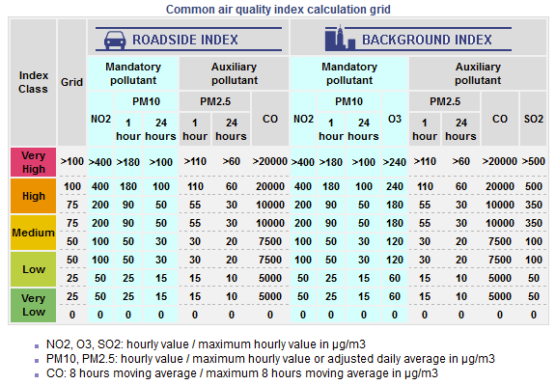

**US EPA Air Now Air Quality Index**

The index is the result of the work of US EPA Air Now calculator, available at airnow.gov and it is used mainly in the US. However, there are global air quality sites and data that use it. For example, http://aqicn.org which gives air pollution information in real time for the whole world and correlates this to heath implications.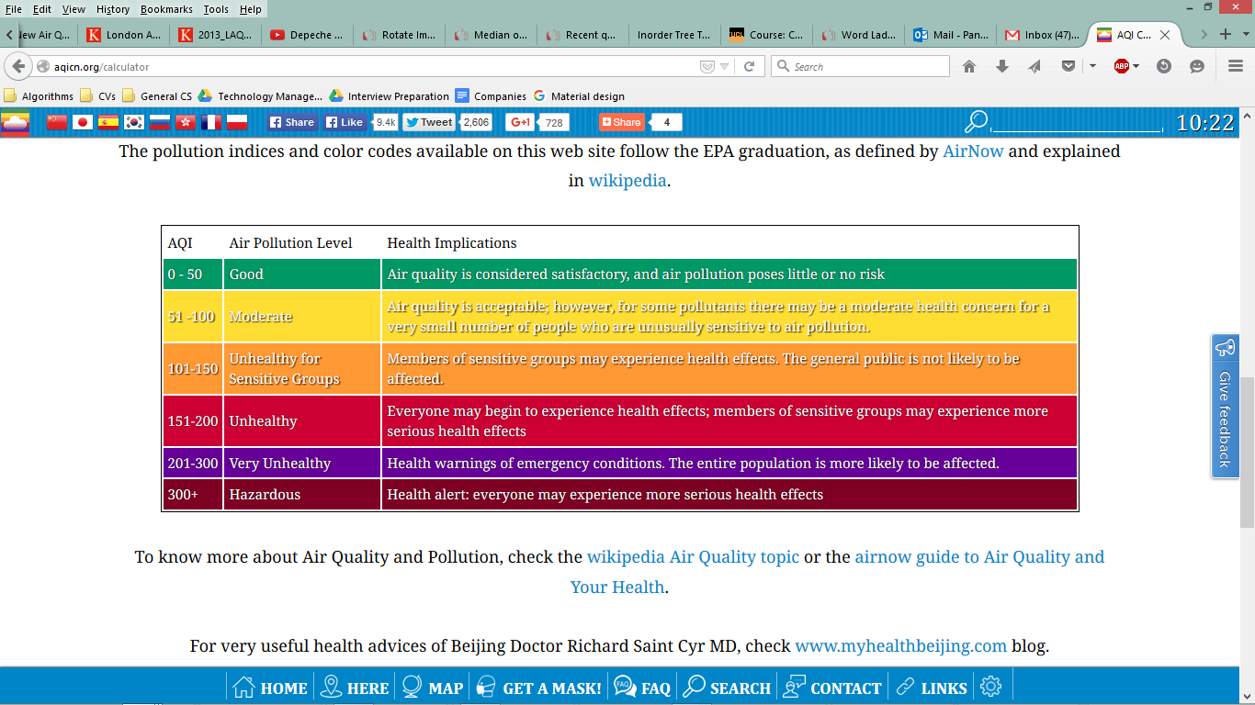**[11]**

We need information on quantifying the effects of exposure (over time) with the health so we can set our goal to be to reduce health risks by a x%.

**Stuff to look into**

ESA’s PROMOTE project

<http://cleanair.london/apps/>

<https://play.google.com/store/apps/details?id=org.cleanairinlondon.cities>

<http://cleanair.london/clean-air-in-cities/>

<http://www.airnow.gov/index.cfm?action=aqibasics.aqi>

1. <http://uk-air.defra.gov.uk/air-pollution/uk-eu-limits>
2. <http://www.legislation.gov.uk/uksi/2010/1001/regulation/2/made>
3. <http://ec.europa.eu/environment/air/quality/legislation/directive.htm>
4. <http://ec.europa.eu/environment/air/quality/standards.htm>
5. <http://www.legislation.gov.uk/uksi/2010/1001/regulation/2/made>
6. <https://www.london.gov.uk/priorities/environment/clearing-londons-air>
7. <http://ec.europa.eu/environment/legal/law/press_en.htm>
8. <http://uk-air.defra.gov.uk/air-pollution/daqi?view=more-info&pollutant=pm10#pollutant>
9. <http://www.londonair.org.uk/london/asp/airpollutionindex.asp?la_id=&region=0&bulletin=hourly&site=&bulletindate=20/10/2015&level=All&MapType=Google&VenueCode=&zoom=7&lat=50.932934051592525&lon=1.0213808339844022&Species=All&laEdge=&WhoBulletin=>
10. <http://www.obsairve.eu/index.php?option=com_content&view=article&id=7&Itemid=129&lang=en>
11. <http://aqicn.org/calculator>